FUNCTIONAL REQUIREMENTS:
- As a patient, I want to register an account, so I can book and manage my appointments.
- As a patient, I want to log in to my account, so I can access my personal appointment dashboard.
- As a patient, I want to book a new appointment with a preferred doctor, so I can receive medical consultation.
- As a patient, I want to reschedule an existing appointment, so I can adjust to my changing availability.
- As a patient, I want to cancel an appointment, in case of emergency.
- As a patient, I want to view my upcoming appointment and past appointments, so I can track my clinic visit.
- As a doctor, I want to log in to my account, so I can manage my schedule and appointments.
- As a doctor, I want to set and update my availability, so I can control when I am open for appointments.
- As a doctor, I want to view my daily schedule, so I can prepare for my consultations.
- As a doctor, I want to mark an appointment as completed or cancelled so my schedule states accurate.
- As a doctor, I want to receive notifications about new or updated appointments, so I can respond promptly.
- As a staff member, I want to log in to the system, so I can manage clinic-wide appointments.
- As a staff member, I want to view the overall appointment schedule for all doctors, so I can monitor clinic operations.
- As a staff member, I want to assign and reassign appointments to doctors, so I can balance the workload.
- As a staff member, I want to prevent overbooking, so I can avoid scheduling conflicts.
- As a staff member, I want to send manual notifications to patients and doctors, so I can communicate important updates.
- As a staff member, I want to generate basic schedule reports so I can support administrative decisions.
NON-FUNCTIONAL REQUIREMENTS:
- The system must be distributed and support microservices architecture to ensure scalability and usability.
- The system must ensure high availability and reliability to minimize downtime during clinic hours.
- The system must use secure authentication and authorization mechanisms to protect user data.
- The system must encrypt sensitive patient data both in transit and at rest.
- The system must be accessible via web browser on both desktop and mobile devices.
- The system must support concurrent access by multiple users (patients, doctors, staff) without performance degradation.
- The system must be tested continuously to ensure functionality and usability before deployment.
- The system must log all critical actions (e.g., booking, cancellation) for audit purposes.

USE CASE DIAGRAM

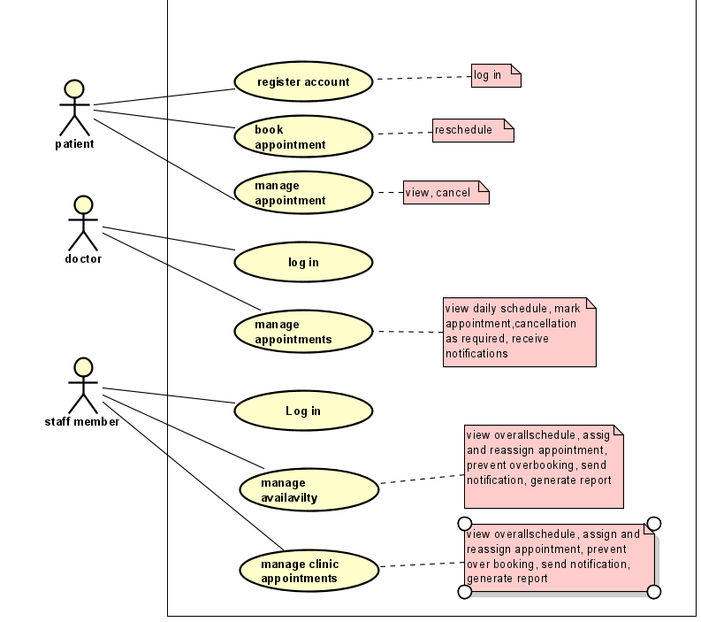

USE CASE DESCRIPTION

Book Appointment.
Use Case | Book Appointment
Summary | To allow a registered patient to schedule appointments.
Actor | Patient
Pre-condition | The patient must be logged into their account.
Post-condition | A new appointment has been confirmed and added to the system.
Main Scenario | - The patients select “book appointment”.  - The system displays available doctors and time slots.  - The patient chooses a doctor and preferred time.  - The system checks for scheduling conflicts.  - The patient confirms the appointment details.  - The system creates the appointment and sends a confirmation notification.
Alternate Scenario | [ALT 1] If no slots are available, the system suggests alternative dates/times.  [ALT 2] If a scheduling conflict is detected, the system prompts the patient to choose another time.  [ALT 3] If the patient exits without confirming, no appointment is booked.
Note | This use case covers functional requirements 1, 3 and Non-functional 2,6.

Register Account.
Use Case | Register Account
Summary | To allow a new user to register as a patient in the system.
Actor | Patient
Pre-condition | The user is not registered in the system.
Post-condition | A new patient account is created and active.
Main Scenario | - The user selects “Register Account”.  - The system displays the registration form.  - The user enters personal details (name, email, phone, password).  - The system validates the entered data.  - If valid, the system creates an account and confirms registration.
Alternate Scenario | [ALT 1] If the email is already registered, the system prompts for a different email.  [ALT 2] If required fields are missing or invalid, the system displays an error message.  [ALT 3] If the user cancels, no account is created.
Note | This case covers functional requirement 1 and Non-functional requirement 3,4.

Manage appointment.
Use Case | Manage Appointment.
Summary | To allow a doctor to update the status of patient appointments.
Actor | Doctor.
Pre-condition | The doctor must be logged into the system and have scheduled appointments.
Post-condition | The appointment status is updated in the system.
Main Scenario | - The doctor selects “manage appointments”.  - The system displays doctor’s daily schedule.  - The doctor selects an appointment and updates its status (e.g., completed, cancelled).  - The system updates the appointment record.  - The system notifies the patient of the status change.
Alternate Scenario | [ALT 1] If the appointment is cancelled, the system may free the time slot for others.  [ALT 2] If the doctor is unavailable, the system allows rescheduling.  [ALT 3] If the update fails, the system retries or logs the error.
Note | This use case covers functional requirements 7, 10. Non-functional 2,8.

Manage Availability.
Use Case | Manage availability.
Summary | To allow staff members to set or update doctors’ working hours and availability.
Actor | Staff.
Pre-condition | The staff must be logged into the system.
Post-condition | The doctor’s availability is updated in the system.
Main Scenario | - The staff selects “manage availability”.  - The system displays the current schedules of all doctors.  - The staff selects a doctor and modifies their working hours/days.  - The system validates the changes against existing appointments.  - The staff confirms the updates.  - The system saves the new availability.
Alternate Scenario | [ALT 1] If changes conflict with existing appointments, the system alerts the staff.  [ALT 2] If the doctor is on leave, the staff can mark them as unavailable.  [ALT 3] If the updates fail, the system rolls back changes.
Note | This use case covers functional requirements 8, 15. Non-functional 1,6.

